Common Game Development Problems and Proposed Solutions
Ryan Askew
Computer Science
Texas State University
raa97@txstate.edu

Abstract
Game development produces a different kind of product than most other types of software. Rather than provide a useful utility to users, games seek to provide entertainment through the use of user interaction, graphics, and sounds, among other multimedia assets. Even so, game development teams can utilize software engineering techniques in order to produce quality games on time and on budget. However, the software engineering techniques used should be customized to fit the needs of the complex process of game development.

Currently in the game industry, very few projects are actually finished on time and on budget, but adapting software engineering techniques to the game industry could help to change that. Specifically discussed in this paper is the use of a lightweight agile approach and prototyping during the preproduction stage of game development, as well as the benefits that will be realized later on in the game development process if these approaches are used.^{[1]}

Key words
game development, video games, software engineering, prototyping, agile method, waterfall method, incremental method, iterative method, preproduction

Introduction
Before the game industry crashed in the mid 1980's, informal incremental and iterative development models were commonly used to develop games. According to Clinton Keith, who currently provides consulting to game development companies, these informal approaches to game development started to break down as games grew more complicated, so the industry began to use traditional software engineering methods, including the waterfall model (the most common at the time).^{[3]} In the modern video game industry, traditional methods are still widely used. Most game development companies use an iterative approach, with a similar number using the waterfall model, and only a few using a hybrid between the two methods or an ad-hoc method.^{[2]}

In the modern world of game development, games are increasingly complex and stunning software products. As a result, time and budget constraints for games are typically not met.^{[5]} With the modern game development process comes challenges such as addressing unplanned features, bugs and glitches, and other unexpected problems that may arise during the development process. Proven software engineering techniques should be adapted to the preproduction stage of the game development process in order to limit the extent of problems like these that will inevitably show up in later stages of development. This is especially important in the preproduction stage of game development, because that is where creativity and the abstract requirements of a game, such as 'fun,' 'engaging,' or 'absorbing,' merge together with the technical requirements to make a game run, in order to produce a formal Game Design Document (GDD).^{[1, 8]}
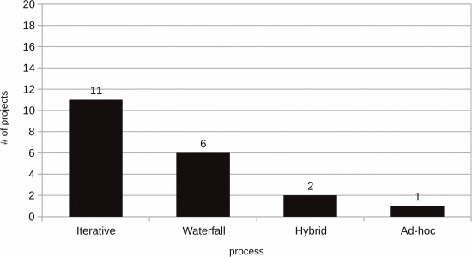
Current Methods and Their Shortcomings
According to Petrillo et al.^{[2]}, out of a sample of 20 game projects, 11 used an iterative model, 6 used a waterfall model, 2 used a hybrid between iterative and waterfall, and 1 used an ad-hoc method. In other words, 55% used an iterative model, 30% used a waterfall model, 10% used a hybrid model, and 5% used an ad-hoc model. These findings are illustrated in figure 1 (right).
Figure 1^{[2]}

The iterative model is explained by Techopedia^{[6]} as a software engineering model in which the entire project is divided into many releases, with builds and updates being released as soon as possible in order to get feedback sooner. This model is closely related to Agile development, so there is less focus on the formal software engineering of the project and more emphasis on continuously releasing updates. This might sound like a good strategy for developing games since versioned releases seem to be popular these days in the game development world. However, because this process is so closely related to Agile, the lack of documentation and proper planning can make the already complicated game development process even more difficult in the long run, even if the project is completed successfully. 55% of games (11 out of 20) surveyed by Petrillo et al,^{[2]} used an iterative model.
The Waterfall model takes each stage of the software development process and goes through them one by one, with little or no opportunity to change anything in the previous stages. This model is best suited for projects whose requirements are already well known before it begins. Games are typically not this kind of project, so it usually does not make sense to use this model for games unless all the requirements are known before the development process begins. Any changes made during development would break from this model. 30% of games (6 out of 20) surveyed by Petrillo et al,^{[2]} used a Waterfall model.
A hybrid model, according to Petrillo et al,^{[2]} combines both the iterative model and the waterfall model during development. Typically, waterfall is used during preproduction and postproduction, and iterative is used during the production stage. This model has the potential to be a good compromise between the previous two for use in game development, but using the waterfall process in preproduction has the potential to limit creativity before a game is even developed. 10% of games (2 out of 20) surveyed by Petrillo et al,^{[2]} used a hybrid model.
Ad-Hoc, according to Petrillo et al,^{[2]} is any previously undefined approach that is specific to each project and can be changed on demand based on the current needs of the project. This style would have very little structure, so would most likely only be useful on small scale game development projects. Ad-Hoc should not be confused with Agile development, even though the two are somewhat similar. Agile development actually has a predefined structure, while Ad-hoc development is undefined and is made up as the development process progresses. 5% of games (1 out of 20) surveyed by Petrillo et al,^{[2]} used an Ad-Hoc method.

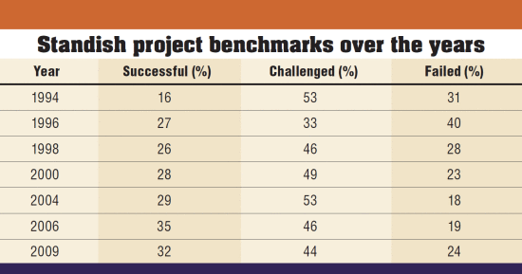
Success Rates and Errors
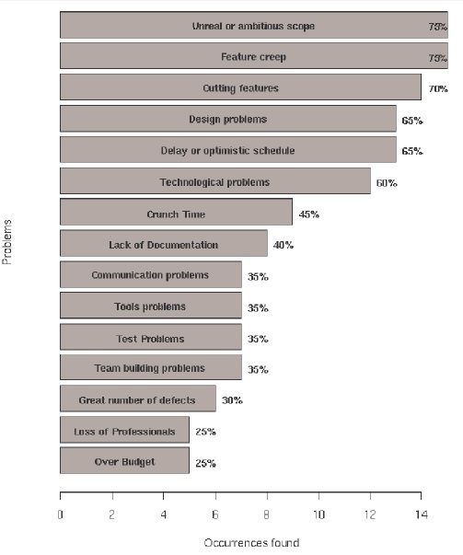
According to the Standish Group's 1995 report,^{[4]} only 16% of all software projects were completed on time and on budget. Even worse, the report claims that only 9% of software projects from large companies were completed on time and on budget. It was also noted in the report that of the many 'complete' projects (on time and on budget), many were "no more than a mere shadow of their original specification requirement." More recently, Verhoef and Eveleens published a paper questioning the Standish Group's findings in their biannual report.^{[5]} In this paper, the Standish Group's findings from 1994 – 2009 were presented (shown in figure 2, above), and the percentage of software projects said to be completed on time and on budget peaked at 35% in 2006, and went back down to 32% in 2009. If these numbers are taken as a ballpark figure, then it is safe to assume that most software projects do not finish on time and on budget, although some improvement has been seen over the years. This is concerning for the field of software engineering as a whole, and not just game development. However, we will now take a closer look at problems specific to the game development industry.
Figure 2^{[5]}

According to data gathered by Petrillo et al,^{[7]} (shown in figure 3, right) the most common errors in the game development process that led to projects being over budget or late, according to Petrillo's data, were over-ambitious project scopes, feature creep, cutting features during development, design problems, unrealistic schedules, technological problems, crunch time, and lack of documentation. We will focus on those issues mentioned which fall under the preproduction stage of the game development process.
Over-Ambitious Project Scope: As noted by Petrillo et al,^{[7]} major problems can arise when a project's scope is not clearly defined. When this is the case, new requirements are going to be added during development, which is not good and can lead to restructuring an entire project. 75% of game projects surveyed by Petrillo et al,^{[7]} encountered this problem.
Figure 3^{[7]}
Feature Creep: Feature creep is defined by Petrillo et al^{[7]} as the addition of new functionalities during the development phase, increasing a project's size. This is directly related to, but not exclusive to, projects with an over-ambitious scope, where new features will inevitably be added throughout development because the game's requirements were never fully defined from the start. Feature creep can arise due to programmers including new "interesting or attractive features during development," usually without "a strong effort of requirements analysis."^{[7]} 75% of game projects surveyed by Petrillo et al,^{[7]} encountered this problem.
Unrealistic Schedules: Many times game projects start out with well-defined schedules, but those schedules tend to be optimistic. Things are bound to go wrong, changes will be made, unexpected delays can arise, and inevitably the project will not be finished in the amount of time allotted.^{[7]} Additionally, according to Flynt and Salem,^{[8]} the probability of success is greatly diminished if a game is released shortly after the release of a competing game, but releasing a defective version sooner than the competing game is no better. 65% of game projects surveyed by Petrillo et al,^{[7]} encountered this problem.
Lack of Documentation: Any large software project should be well documented, especially when it comes to the complicated endeavor of game development. Indie developers creating small games may be able to get away with sparse documentation, but the majority of game developers working on larger games should follow good documentation practices, especially during preproduction, in order to avoid unexpected complications and delays later in the development process.

The Problem
As is evident from the previous sections in this paper, there are problems in the software engineering industry, but specifically within game development. These problems are likely a result of, among other factors, not fully adapting modern software engineering techniques to the complicated process of game development, specifically in the preproduction stage. The software processes most commonly adopted by game developers noted by Petrillo et al.^{[2]} (iterative, waterfall, hybrid, ad-hoc) do not fully address the unique needs and requirements of game development and the type of software product that it produces. The ability to produce a game that is 'fun,' 'engaging,' 'entertaining' or 'absorbing' can be subjective and requires human touch.^{[1, 8]} It is reasonable to conclude, then, that the strict models most commonly used for modern game development do not sufficiently allow for the flow of creativity into a game, as evidenced by the statistics discussed earlier.^{[2, 7]} Clearly, improved adaptations of modern software engineering techniques must be applied to the game development process in order to alleviate some of the common problems faced by the game development industry today.^{[1]}

The Solution
A straightforward solution to this problem, according to Kanode and Haddad,^{[1]} is to separate the game development process into preproduction and production and use different adapted software engineering methods during each stage. Preproduction would utilize a lightweight Agile approach, which would include the creative process and lots of prototyping in order to find out what the game is about.^{[1]} At the end of this process, the Game Design Document (GDD) would be created, which would then be used in the production stage, where an incremental waterfall approach would be used. This paper will focus on the preproduction aspects of this solution and the importance of the GDD for the future stages of game development.

Lightweight Agile and Prototyping
According to Kanode and Haddad,^{[1]} "using lightweight Agile methods during preproduction could be advantageous in exploring game playability and user interaction." Using this approach, developers could let their creative juices flow, so to speak, before the actual game development process begins. This way, all the experimentation has been done in preproduction and there should be little, if any, need to experiment during the more formal production process. The game's fun, engaging features could be discovered in this stage of development without hindering the game's progress later on, because the actual implementation has not begun yet. In fact, this process would aid in the design of the game by adding these newly discovered features to the GDD to be fully developed later in the process. According to Schofield,^{[10]} a proponent of using XP in game development who is mentioned by Kanode and Haddad,^{[1]} XP can be used to facilitate finding these types of features quicker so that they can be added to the GDD and accelerate development.

The common problem among game development projects of having an unrealistic scope^{[7]} could be addressed by doing a lot of prototyping during preproduction, which would happen alongside the lightweight Agile method used for idea generation. Prototyping in these early stages of game development could greatly aid in keeping the scope of the project under control, because the developers can actually see what the proposed features would be like in the game and what it would take to actually implement them. Rather than expanding the project scope every time a new feature is proposed, potential features could have a preliminary implementation in one of the game's prototypes in order to test their feasibility. No matter how many prototypes it takes, developers should focus on finding all the features that should be in the game while culling those features that are not necessary or are unrealistic to implement. This way, the production phase of development can focus on implementation instead of coming up with new features.

Importance of the GDD (Game Design Document)
According to Kanode and Haddad,^{[1]} creating a good GDD has many long term benefits to the game development process. The GDD is a description of the game, which can include "storyboards, concept artwork, paper prototypes, software prototypes, and much more."^{[1]} The main benefit to creating a GDD is that it helps to establish the game as a set of real requirements instead of something imaginary and of unknown size that someone has dreamed up. It helps to keep things realistic while leaving room for the creative process during preproduction before the document is finalized. The GDD provides a means by which to establish targets and gather requirements for a game in order to keep the project's scope under control, and to prevent feature creep from taking over by avoiding unplanned features.^{[1]}

When the prototyping process is completed and the development team believes that it has found all requirements for the game, then the GDD should be finished and double checked for correctness before moving on to the actual development process. According to Kanode and Haddad,^{[1]} proper "requirements engineering can help gather the stated and unstated requirements for the project." They also noted that bringing all multimedia teams together could help establish how realistic a project's scope is, and proper risk management could help a project manager understand the risks associated with changes to the project's plan or to the actual GDD. With the game's requirements firmly in place, there should be little room for problems such as feature creep later in the development process, and the issues of project scope and documentation should be resolved.

This combination of lightweight agile with prototyping during preproduction can help move the creative process of game development forward before the actual implementation process begins. This way, no creative ideas will be left out and the development team is not restricted to what they can come up with as far as game features and content are concerned. Additionally, the project should have a higher chance of success because its requirements will be well documented in the GDD. These processes should provide a smooth transition from a vague concept to specific requirements that the game will have, which can be formally adopted when the GDD is written. With the project's scope deemed to be realistic and all requirements gathered, the GDD can then be used as a design document to guide the rest of the development process in the production phase, where the development team can focus on implementation.

Conclusion
Current methods used for software engineering in the game development industry are lacking. The iterative, waterfall, hybrid, and ad-hoc methods are the most common for modern game development. However, these are not well adapted for the unique needs of the game development industry, which combines multimedia assets such as graphics, sounds, interaction, and more to provide a software product that is entertaining to the end user. Strictly following modern software engineering models are not necessarily a good fit for game development, since the product produced does not provide a useful utility to users, but combines so many multimedia teams and assets into an entertaining software product. Many of the requirements of games are subjective, such as 'fun' and 'exciting,' which are difficult to model when using strict software engineering models. It is clear that modern methods should be adapted to meet these unique needs of the game development industry.

The solution, proposed by Kanode and Haddad,^{[1]} is for teams to divide the game development process into preproduction and postproduction, and use different adapted software engineering methods for both stages. The method used during preproduction should be a combination of a lightweight Agile method and prototyping, and the production stage should incorporate an incremental waterfall approach. This paper focused on the solution for the preproduction stage of game development proposed by Kanode and Haddad.^{[1]} By using a lightweight agile approach during preproduction, creativity can flow and as many ideas as possible can be brought to the table without hindering the rest of the development process. Many prototypes should be made in this stage in order to test the feasibility of each idea and feature so that the vast majority of requirements can be recorded in the Game Design Document (GDD), which can then be used in the production stage of development. If this solution is implemented, development teams should have a well-defined project scope and set of requirements for the games that they develop before the actual implementation process begins, and their projects should have a higher chance of success.

References
[1] Kanode, C.M., and Haddad, H.M., "Software Engineering Challenges in Game Development," Information Technology: New Generations, 2009. ITNG '09. Sixth International Conference on, [online], pp. 260-265, http://ieeexplore.ieee.org.libproxy.txstate.edu/xpls/icp.jsp?arnumber=5070627
[retrieved April 24, 2017].

[2] Politowski, C., Fontoura, L., Petrillo, F., and Guéhéneuc, Y.G., "Are the Old Days Gone? A Survey on Actual Software Engineering Processes in Video Game Industry," Games and Software Engineering (GAS), 2016 IEEE/ACM 5th International Workshop on, [online], http://ieeexplore.ieee.org.libproxy.txstate.edu/document/7809512/ [retrieved April 24, 2017].

[3] Keith, C., "Get in the Game: What others can learn from game developers," Better Software Magazine, [online], November 2006, http://www.agilegamedevelopment.com/ [retrieved April 24, 2017].

[4] The Standish group, "The Standish Group Report Chaos," [online], 1995, https://www4.in.tum.de/lehre/vorlesungen/vse/WS2004/1995_Standish_Chaos.pdf [retrieved April 24, 2017].

[5] Eveleens, J., and Verhoef, C., "The Rise and Fall of the Chaos Report Figures," IEEE Software, [online], Volume 27, Issue 1, pp. 30-36, http://ieeexplore.ieee.org.libproxy.txstate.edu/document/5232804/ [retrieved April 24, 2017].

[6] "Iterative Development," Techopedia, [online], https://www.techopedia.com/definition/26100/iterative-development [retrieved April 24, 2017].

[7] Petrillo, F., Pimenta, M., Trindade, F., and Dietrich, C., "Houston, We Have a Problem…: A Survey of Actual Problems in Computer Games Development," Proceedings of the 2008 ACM Symposium on Applied Computing,[online], pp. 707-711, http://dl.acm.org.libproxy.txstate.edu/citation.cfm?id=1363854&CFID=926799074&CFTOKEN=98781455 [retrieved April 24, 2017].

[8] Flynt, J. P., and Salem, O., "Software Engineering for Game Developers," Software Engineering Series, Course Technology PTR, 1st edition, November 2004.

[9] Callele, D., Neufeld, E., and Schneider, K., " Requirements engineering and the creative process in the video game industry," Requirements Engineering, 2005. Proceedings. 13th IEEE International Conference on, [online], http://ieeexplore.ieee.org.libproxy.txstate.edu/document/1531045/ [retrieved April 24, 2017].

[10] Schofield, B., "Embracing Fun: Why Extreme Programming is Great for Game Development," [online], http://www.gamasutra.com/features/20070301/schofield-01.shtml [retrieved April 24, 2017].

